|  |  |
| --- | --- |
| **crop pulse**  **YOUR FARMING FRIEND** | **Abstract**  **AI-Driven Crop Health Surveillance for Early Detection and Precision Agriculture.**  **TEAM NAME**  **TEAM SPARKS** |

**1. Problem Statement**

Develop an AI-powered crop health assistant using live APIs and satellite imagery to detect diseases, assess pest risks, and recommend fertilizer usage to boost yield and productivity.

**2. Project Title**

**CROP PULSE:** AI-Driven Crop Health Surveillance for Early Detection and Precision Agriculture

**3. Abstract**

Crop Pulse leverages computer vision and machine learning to analyze satellite and image data for early detection of crop diseases, nutrient deficiencies, and pest threats. It empowers farmers with real-time, actionable insights to reduce crop loss and promote sustainable farming.

**4. Introduction**

* Challenges: Disease outbreaks, climate unpredictability, and inefficient manual monitoring
* Need for Automation: Manual inspection is slow, subjective, and labor-intensive
* AI Role: Enables scalable, consistent, and real-time crop diagnostics

**Project Goals:**

* Early detection of crop diseases
* Geotagged health reports for spatial tracking
* Decision support for farmers and agronomists
* Initial focus on tomato, rice, and cotton crops

**5. Existing Systems & Limitations**

* Manual Inspection: Time-consuming, error-prone, reliant on farmer experience
* Satellite Imaging: Low resolution, infrequent updates
* Mobile Apps: Limited disease sets, delayed feedback

**Limitations:**

* Reactive rather than proactive
* Poor geospatial integration
* Not scalable for large farms

**6. Key Features**

* Real-time disease detection
* Geotagged health reports
* Intuitive, farmer-friendly dashboard

**7. Benefits**

* Enables early intervention and timely treatment
* Reduces unnecessary pesticide usage
* Improves yield, profitability, and sustainability

**5. Proposed System**

**System Design:**

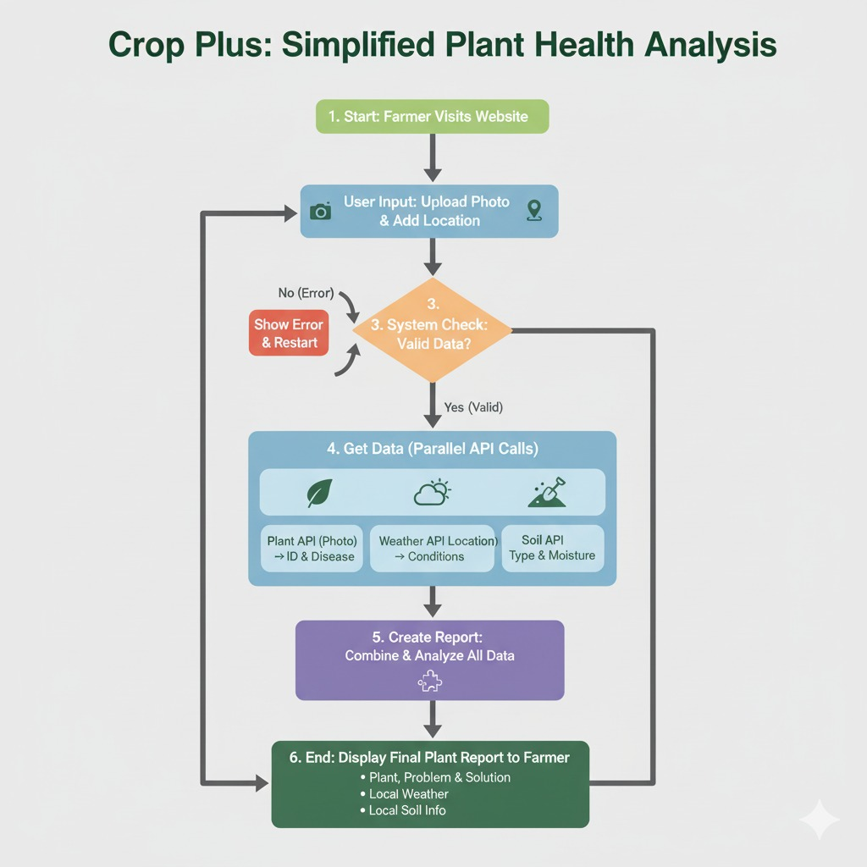

**TECHNLOGIES USED:**

1. **Frontend:** Built with React.js for a fast, modular, and responsive user interface.
2. **Backend:** Powered by Spring Boot to expose RESTFUL APIs and manage business logic.
3. **Database:** Uses MySQL to store structured data like user profiles, crop records, and diagnostics.
4. **AI Integration:** Connects to external or internal AI Agent.
5. **Security**: Implements Spring Security for authentication and role-based access control.
6. **Scalability:** Supports microservices architecture for modular deployment and future expansion**.**
7. **Localization:** Can be extended with multilingual and offline support for rural accessibility.
8. **Real-time Data:** Can integrate Kafka or RabbitMQ for streaming sensor.

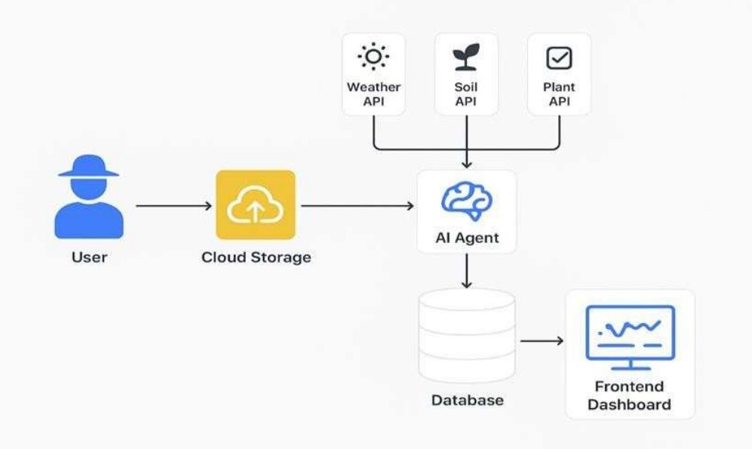

**Prototype Walkthrough and Features:**

1. **Login/Signup**: Users authenticate securely to access personalized crop monitoring features.
2. **Dashboard**: Displays crop health status, alerts, weather forecasts, and upcoming tasks.
3. **Crop Catalog**: Users browse or select from a catalog of supported crops with region-specific disease profiles.
4. **Crop Registration**: Farmers input crop type, location, and planting date for tracking and diagnostics.
5. **Image Upload & Analysis**: Users upload crop images; backend invokes AI models for health assessment and stores results in MySQL.
6. **AI Chatbot**: A multilingual chatbot assists users with queries, crop advice, and navigation—supports text and voice input/output.
7. **Actionable Insights**: Health results are visualized with treatment suggestions, irrigation, and pest control schedules.
8. **Notifications**: SMS alerts are sent for critical events like watering, pest outbreaks, or fertilizer schedules based on crop stage.

**Prototype Demo:**

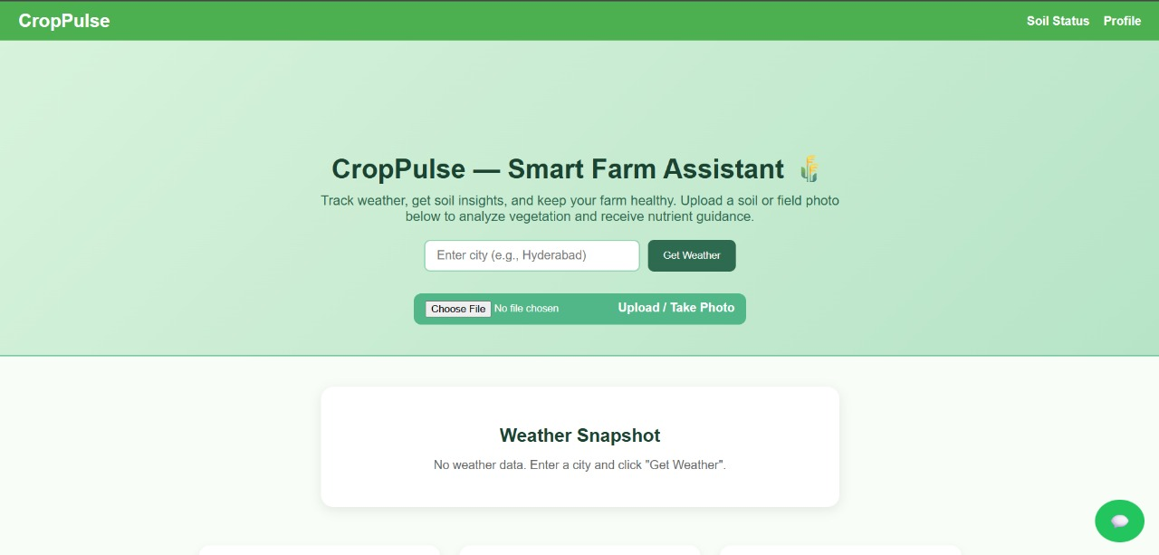

**How it’s Works:**

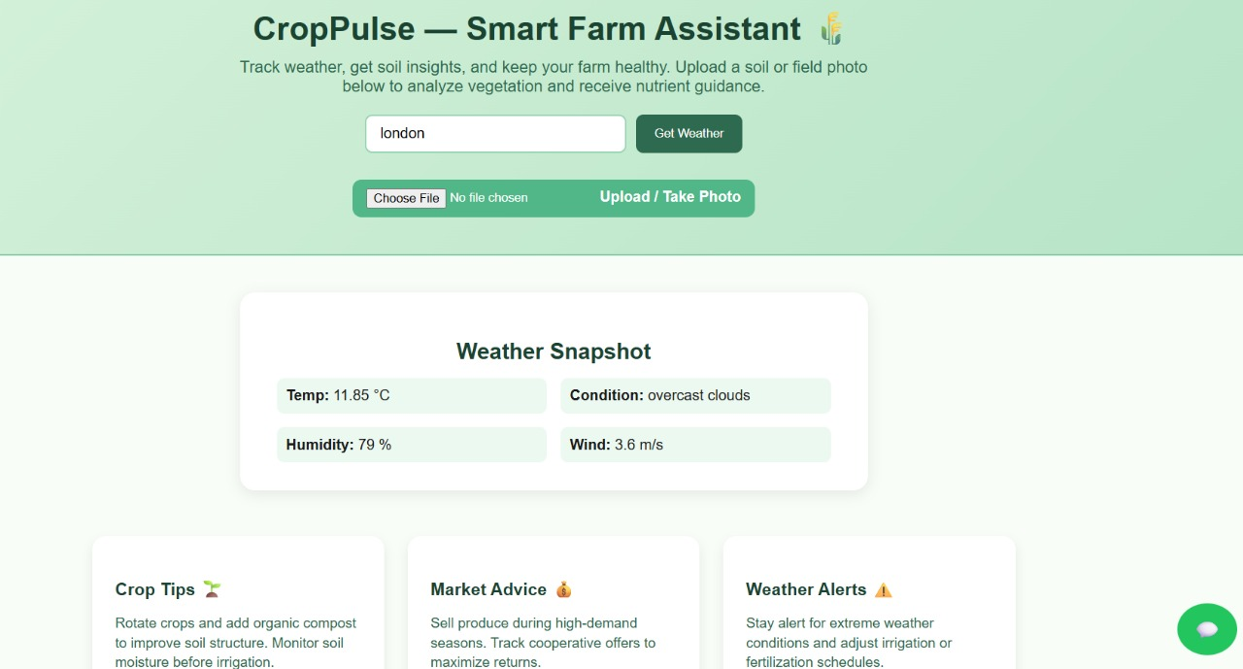

Weather Snapshot

Weather Report

Upload Crop Photo

Plant Report Chatbot

**Market Viability of Crop Pulse:**

1. **Growing Demand**: With increasing climate variability and pest outbreaks, farmers are actively seeking predictive tools to reduce crop loss and improve yield reliability [iarjset.com](https://iarjset.com/wp-content/uploads/2025/09/IARJSET.2025.12907.pdf) [IEEE Xplore](https://ieeexplore.ieee.org/document/10398035).
2. **AI Adoption in Agriculture**: The global market for AI in agriculture is expanding rapidly, driven by advancements in computer vision, remote sensing, and machine learning for disease detection and nutrient management [IEEE Xplore](https://ieeexplore.ieee.org/document/10398035).
3. **Proven Use Cases**: Platforms like Plantix (India), Agremo (Europe/US), and IBM Watson Decision Platform have demonstrated the effectiveness of AI in real-time crop monitoring, validating the model Crop Pulse is built on [JETIR](https://www.jetir.org/papers/JETIRGV06096.pdf).
4. **Government & NGO Support**: Many governments and agricultural development agencies are funding digital agri-tech pilots, especially those that support smallholder farmers with scalable, low-cost solutions [iarjset.com](https://iarjset.com/wp-content/uploads/2025/09/IARJSET.2025.12907.pdf).
5. **Data-Driven Ecosystem**: Crop health data is increasingly valuable for insurers, agri-input firms, and commodity traders, creating opportunities for B2B partnerships and data monetization [IEEE Xplore](https://ieeexplore.ieee.org/document/10398035).
6. **Mobile-First Advantage**: With rising smartphone penetration in rural areas, mobile-based AI tools with multilingual ,sms notification and voice support (like Crop Pulse) are well-positioned for adoption.
7. **Sustainability Alignment**: Crop Pulse aligns with global sustainability goals by promoting efficient input use, reducing chemical overuse, and supporting climate-resilient farming.
8. **Scalable Architecture**: The use of React.js, Spring Boot, and MySQL enables modular scaling, while AI integration allows for continuous improvement and regional adaptation.
9. Here’s a minimized version of the flowchart in table format, keeping only the essentials:

| **Focus Area** | **Key Points** |
| --- | --- |
| **Challenges** | Crop loss, poor diagnostics, weather instability |
| **Target Users** | Small farmers, cooperatives, agri firms |
| **Adoption Drivers** | Govt schemes, supply chains, WTP, compliance |
| **Monetization** | Subsidies, sustainability, mobile-first model |
| **Tech Opportunity** | Success of Plantix, CropIn |
| **Competition** | Existing gaps, differentiation |
| **Scalability** | Robust tech stack, regional/crop expansion |
| **Outcome** | **High Market Viability** |

**Existing Platforms:**

1. **Plantix**
   * Focuses on AI-based image recognition for diagnosing plant diseases and nutrient issues.
   * Key Difference: Prioritizes diagnosis and treatment; lacks integrated dashboard or satellite/weather data.
2. **AgriBazaar**
   * Provides mandi prices, e-commerce for farm inputs, and limited advisory.
   * Key Difference: Emphasizes marketplace and supply chain; not focused on AI-driven crop health monitoring.
3. **Cropin**
   * Offers satellite imagery, weather data, and predictive analytics for large-scale farm management.
   * Key Difference: Targets enterprises and governments; not designed for individual smallholder farmers.
4. **DeHaat**
   * Delivers crop advisory, input sales, and market access through local centers.
   * Key Difference: Relies on human experts and physical infrastructure; less automation.
5. **KhetiGaadi**
   * Specializes in buying, selling, and renting farm machinery.
   * Key Difference: Focused on equipment commerce; not involved in crop health diagnostics.
6. **IFFCO Kisan App**
   * Offers weather forecasts, mandi prices, crop info, and farmer helpline.
   * Key Difference: Primarily informational; lacks AI-based health monitoring and automation.

| **Feature** | **Crop Pulse** | **EOS Crop Monitoring** | **Plantix** | **One Soil** |
| --- | --- | --- | --- | --- |
| Core Purpose | AI crop & soil health monitoring | Satellite-based analytics | Pest & disease detection via images | NDVI and weather-based crop tracking |
| Notifications | SMS & in-app (multilingual, voice) | Email & app alerts | App notifications | App-based alerts |
| AI Chatbot | Yes (multilingual + text-to-speech) | No | Basic FAQs | No |
| Product Catalog | Yes (AI-linked agro catalog) | No | Limited advisory only | No |
| Language Support | Global & regional | English only | 10+ languages | Limited |
| Offline Use | Yes | Partial | Yes | Yes |
| Visualization | Graphs + AI insights | Satellite maps | Image-based diagnosis | NDVI vegetation maps |
| Unique Edge | Conversational AI + SMS + TTS | Precise satellite data | Simple disease ID | Free and easy-to-use app |

**Future Scope for Crop Pulse:**

1. **Expanded AI Capabilities**: Integration of generative AI for predictive modeling, early disease forecasting, and adaptive treatment recommendations.
2. **Sensor & IoT Integration**: Real-time data from soil sensors, drones, and weather stations to enhance precision and automate alerts.
3. **Voice-Driven Interface**: Full voice assistant support for farmers with low literacy, including regional language commands and responses.
4. **Offline Functionality**: Enhanced offline mode with periodic sync for areas with poor connectivity.
5. **Blockchain Traceability**: Secure crop history tracking for organic certification, insurance, and supply chain transparency.
6. **Marketplace Embedding**: Direct purchase of recommended inputs (fertilizers, pesticides) based on AI diagnostics.
7. **Financial Services Integration**: Crop health data used for loan eligibility, insurance claims, and yield-based credit scoring.
8. **Global Expansion**: Localization for other regions with crop-specific models, language packs, and regulatory compliance.

**Conclusion :**

* Crop Pulse addresses a critical need for real-time, AI-powered crop health monitoring among smallholder farmers.
* The platform leverages a robust tech stack (React.js, Spring Boot, MySQL) for scalability and performance.
* Its unique features—AI chatbot, multilingual support, text-to-voice, and SMS alerts—enhance accessibility and usability.
* Market viability is strong, supported by rising demand for precision agriculture and digital advisory tools.
* It stands out from existing platforms by combining diagnostics, advisory, and market linkage in one unified solution.
* Monetization is feasible through subscriptions, per-acre diagnostics, B2B licensing, and data services.
* Future scope includes IoT integration, blockchain traceability, and expansion into new regions and crops.
* Crop Pulse is well-positioned to drive sustainable, tech-enabled transformation in agriculture.

**Research & References**

**Academic Studies**

* **“AI in Agriculture: A Review” – IEEE Xplore (2023)**   
  Covers machine learning and computer vision applications in crop disease detection, yield prediction, and soil analysis.  
  [Link to paper](https://ieeexplore.ieee.org/document/10398035)
* **“Comparative Study of AI-Based Crop Monitoring Platforms” – JETIR (2024)**   
  Evaluates platforms like Plantix, Cropin, and DeHaat, identifying gaps in automation and accessibility.  
  [Link to paper](https://www.jetir.org/papers/JETIRGV06096.pdf)
* **“AI-Powered Crop Monitoring in India” – IARJSET (2025)**   
  Focuses on mobile-first design, multilingual support, and smallholder adoption in rural India.  
  [Link to study](https://iarjset.com/wp-content/uploads/2025/09/IARJSET.2025.12907.pdf)

**Industry Platforms**

* **FlyPix AI** – Provides drone and satellite-based crop health monitoring with AI analytics.  
  [FlyPix Blog](https://flypix.ai/blog/crop-monitoring-software-tools-ai/)
* **MapMyCrop** – Offers 360° crop monitoring with WhatsApp-based advisory in regional languages.  
  [MapMyCrop](https://mapmycrop.com/)
* **DevOpsSchool’s Top 10 AI Agriculture Tools (2025)** – Lists and compares leading platforms.  
  [DevOpsSchool Article](https://www.devopsschool.com/blog/top-10-ai-agriculture-tools-in-2025-features-pros-cons-comparison/)

**Market Insights**

* **MarketsandMarkets Report on AI in Agriculture (2025)** – Projects over 25% CAGR for AI agri-tech.
* **AgFunder India Agrifood Tech Investment Report (2024)** – Highlights investor interest in AI-driven crop solutions.
* **World Bank Digital Agriculture Strategy (2023)** – Emphasizes mobile-first, data-driven tools for smallholder empo